2025/08/26 - Intro
(Lecture 01)
How does a computer execute a program?
- It depends on computer architecture
- Computer only understands binary code

Is binary code a programming language?
- Yes but it is very hard for a user to write a program in binary

Programming language == notational system for describing computations in a machine readable and human readable form.

2025/08/28 - Intro to Concepts of Programming Language
(Lecture 02)

PL Implementation methods

Compilation == Programs are translated into machine language
  - Slow translation, fast execution
  - Lexical Analysis: Converts characters in source program to lexical units
  - Syntax Analysis: transforms lexical units to parse trees
  - Semantic Analysis: Generate Intermediate Code
  - Code Generation: Machine code generated

Pure Interpretation == Programs are interpreted by another program known as an interpreter
  - Easier implementation of programs
  - Reduces Von Neumann bottleneck
  - Run time errors can easily and immediately be displayed
  - Slower execution than compiled programs (10-100 slower)

Hybrid Implementation == compromise between compilation and pure interpretation
  - Faster than pure interpretation
  - Solves issues that both had
- Q2.1 = E
- All three can be implemented in a programming language

Von Neumann Bottleneck
- Connection speed between computers memory and processor determines speed of computer
- Program instructions can be executed faster than the speed of connection
- Connection speed causes bottleneck
- Pure interpretation reduces this bottleneck
- Languages are developed around the von Neumann architecture

Imperative Paradigm
- Q2.2 = E
- Q2.3 = C, D, or E
- Any programming language with the following:
  - Sequence based execution
  - Variables representing memory
  - Use of assignments to change variable values
- Expressions are solved for return values
- Primary way to affect computations is through side-effects
- Limitations:
  - Von Neumann bottleneck
  - Computations need not be described as a sequence of instructions
    - Parallel computation
    - Recursion
    - Nondeterministic computation
  - Side Effect makes it difficult to understand

Side-Effects:
  - Computational effects external environment (global variables)
  - How to avoid it?
    - No variables and assignments
    - Variable change through assignments cause most bugs
    - ^^^ this is a key part of the functional programming paradigm

Functional Programming Paradigm
- Closer to math
- Functions == first class entities
- Mostly without variables, assignments, and iteration
- No side-effects

First Class Entity
  - Can be Stored, passed, or returned as a value
- Second Class Entity
  - Only passed as an argument
- Third Class Entity
  - Cannot be passed as an argument

2025/09/02 - Formal Languages and Grammars
(Lecture 03)
Quiz 3.1 = Many depending on views
Quiz 3.2 = B, a lexeme
Quiz 3.3 = A, CPS111
Quiz 3.4 = C
Quiz 3.5 =

Syntax and Semantics
- A Language needs both Syntax and Semantics

Syntax: the form or structure of the expressions, statements, and program units
  - Use grammar to define a formal language
  - Formal language is a set of sentences or strings over some alphabet
  - Syntax terminology
    - Sentence == string of characters over some alphabet
    - Language == set of sentences
    - Lexeme == lowest unit of a language
    - Token == category of lexemes
  - Token Categories
    - Reserved Words / Key Words (if, while, etc)
    - Literals / Constants
    - Special Symbols (“;” “<=” “+”)
    - Identifiers

Semantics: the meaning of the expressions, statements, and program units
- Both Syntax and Semantics provide a language definition

Sentence Validity
  - Lexically validity == All the words of the sentence are valid (words spelled right)
  - Syntactically validity == Lexically valid and the order of the words is valid (words in a readable order)
  - Semantically validity == Syntactically valid and has valid meaning (sentence has a meaning)
- Lexical Structure
  - Tokens are building blocks of syntax, the words of the language per se
  - Tokens are recognized by the scanner, the first phase of a translator
  - Scanners (Lexers) == recognizer of regular expression
    - Typically contain a loop to cycle through characters until you get white space
  - Reserved words (think variable names in c# and stuff like “if” or “while”)
- Regular Grammar == generative devices for regular languages
  - Any finite language is regular
  - Lexemes describes by regular grammar
  - * means 0 or more
  - + means 1 or more of previous character
  - - means a range
  - ^ anything but what comes next
    - Ex: [^a-z] means anything but lowercase
- Regular Expression
  - Used in computer science to describe text patterns
  - Sample: [ 0 - 9 ] + ( \ . [ 0 - 9 ] + ) ?
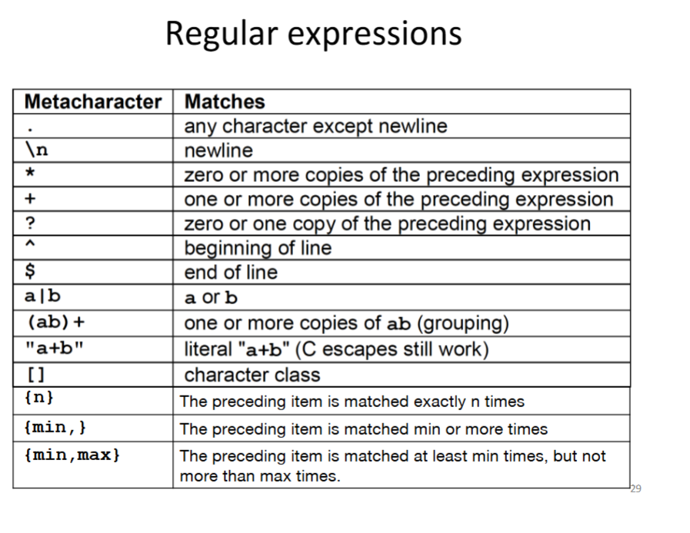
- Exercises:
  - [0-9][0-9][0-9] - [0-9][0-9] - [0-9][0-9][0-9][0-9]
    - Social security number
  - Define a grammar for a variable identifier in C (has to start with _ or any alphabetic character and then be followed by _, any alphabetic character, or numbers
    - [a-z A-Z _] [a-z A-Z _ 0-9]*
  - Write a regular expression for a zip code (either 5 digits or 9 digits with a - after the 5th)
    - [0 - 9] {5} ( [-] [0-9] {4} )?

2025/09/03 - Context Free Grammars
(Lecture 04)
Quiz 4.1 = A
Quiz 4.2 = E
Quiz 4.3 = A

Limitations on Regular Grammars
- Regular grammars are powerful enough to model the lexemes of programming languages
- Regular grammars are not powerful enough to model expressions or statements
  - Can’t do: A = b + c
  - Need another thing to do these, thats where BNF comes in

Context Free Grammars and BNF
- Context-Free Grammars
  - Language generator
  - Meant to describe syntax of natural languages
- Backus-Naur Form (BNF) == equivalent to context-free grammars
  - LHS ::= RHS
    - An LHS (left-hand side) is always non-terminal
    - An RHS (right-hand side) is - a string of terminals and/or - non-terminals
- Lexemes are terminals in BNF
  - Lowest unit in the language
- Tokens are Non-terminals in BNF
  - Category to hold lexemes
  - Think like the category of nouns, all the different person place or things are lexemes but the big category, noun, is the token.
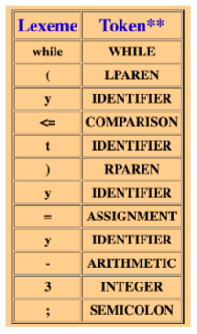
- 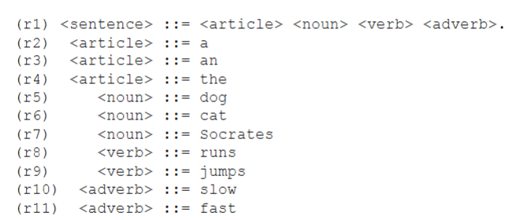
  - This whole thing is a grammar
  - Start symbol = <sentence>
  - Non-terminal = <article>, <noun>, <verb>, <adverb>
  - Terminal = cat, runs, etc.

Language Generation
- Grammars can be used for language generation
- Sentential form == string in RHS containing terminals and non-terminals

Derivation
- Derivation == repeated application of rules starting with start symbols and ending with a sentence
- There are leftmost and rightmost derivations, but not all derivations are either
- Any derivation method will have the same result
- Leftmost
  - Leftmost non-terminal is always replaced first and each step
- Rightmost
  - Rightmost non-terminal is always replaced first in each step

Exercise: Define a context-free grammar (CFG) for arithmetic expressions for a four-function calculator (+ | - | * | /) with integers
(r1) <expression> ::= <number> ( <function> <number> )+
(r2) <number> ::= [-]?[0-9]+
(r3) <function> ::= [+-*/]

Building this function would look like:
<number>
<number> <function>
<number> <function> <number>
<number> <function> 936
<number> + 936
-1 + 936

Exercise: consider the following CFG:
Rightmost derivation of “132”:
(r1) <expr> ::= <number>
(r2-3) <number> ::= <number><digit> | <digit>
(r4) <digit> ::= 0 | 1 | 2 | 3 | 4 | 5 | 6 | 7 | 8 | 9
Answer:
<number>
<number><digit>
<number>2
<number><digit>2
<number>32
<digit>32
132

Exercise: Construct Derivation
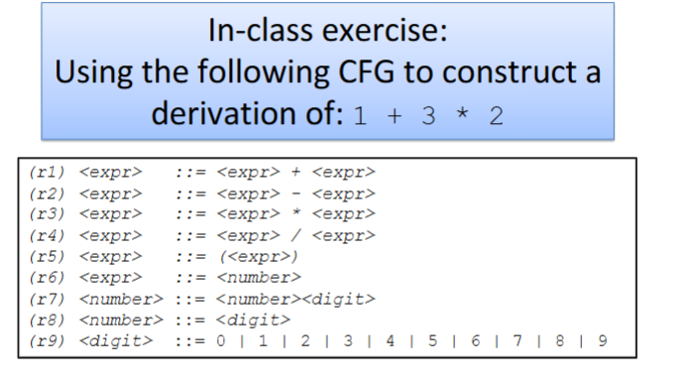
<expr> * <expr> (r3)
<expr> * <number> (r6)
<expr> * <digit> (r8)
<expr * 2 (r9)
<expr> + <expr> * 2 (r1)
<expr> + <number> * 2 (r6)
<expr> + <digit> * 2 (r8)
<expr> + 3 * 2 (r9)
<number> + 3 * 2 (r6)
<digit> + 3 * 2 (r8)
1 + 3 * 2 (r9)

2025/09/09 - Language Recognition
(Lecture 05)
Quiz 5.1: C
Quiz 5.2: B
Quiz 5.3: C
Quiz 5.4: E
Quiz 5.5: E
Quiz 5.6: C

Language Recognition
- Grammars can be used for language generation and recognition
  - Generation = start symbol –> sentence
  - Recognition = sentence –> start symbol
- Parsing == given an input string and grammar we can do a reverse derivation to determine if a string is a sentence
- Parser == Computer program that implements parsing

Parsing: Reverse Derivation
- Scan the string from left-to-right put on a stack
  - “.” (dot) == top of the stack
    - Handle == The RHS of the “.” is the remainder of the string to be parsed
- Apply shift-reduce rule (or bottom-up) as follows
  - If the items at the top the stack match the RHS of any production do the reduce rule, which replaces those items with the non-terminal of LHS of the rule
  - If no match, do the shift rule, which lets you shift the next lexeme
- Parse 1 + 3 * 2
. 1 + 3 * 2 shift
1 . + 3 * 2 reduce
<number> . + 3 * 2 reduce
<expr> . + 3 * 2 shift
<expr> + . 3 * 2 shift
<expr> + 3 . * 2 reduce
<expr> + <number> . * 2 reduce
<expr> + <expr> . * 2 reduce
<expr> . * 2 shift
<expr> * . 2 shift
<expr> * 2 . reduce
<expr> * <number> . reduce
<expr> * <expr> . reduce
<expr> . start symbol
Valid sentence
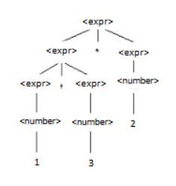
- Can also leave <expr> + <expr> alone and shift to get
<expr> + <expr> * <expr> and then remove the * first
  - This is a shift-reduce conflict
- Both are correct \/

Ambiguous Grammar
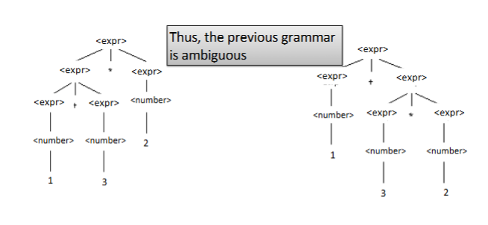
- 2 parse trees for 1 + 3 * 2, therefore it is ambiguous
- Ambiguous == a grammar for a language is ambiguous if there is more than one parse tree for a sentence
  - To prove something is ambiguous, generate an expression from the grammar and then give two parse trees for it
  - Any type of conflict makes something ambiguous (shift-reduce, reduce-reduce)

2025/09/11 - Ambiguity and Disambiguating Grammars
(Lecture 06)
Quiz 6.1: C
Quiz 6.2: A
Quiz 6.3: B
Quiz 6.4: C

Ambiguity
- If a sentence from a language has more than one parse tree, then the grammar for the language is ambiguous
  - Even if the parse trees have the same output
- Causes:
  - Shift-reduce and reduce-reduce conflicts
  - Multiple parse trees generated with different meanings
- Solutions:
  - Higher Operator Precedence
  - Grammar Revision for Precedence
    - Introduce new steps (non-terminals) into the grammar
    - Take the parse error we had with 1 + 3 * 2 for ex

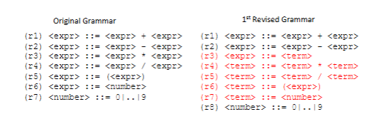
Now the parse tree becomes:

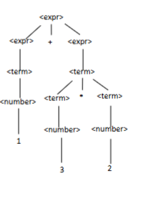

Syntax Desideratum
- Semantics help to determine which parse tree is correct

Associativity
- Comes into play when dealing with operators with the same precedence
  - Left associative vs right associative
  - (6-3)-2 vs 6-(3-2)
- Revise the 1st grammar
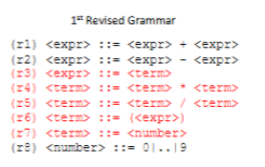
2nd revised grammar
(r1) <expr> ::= <expr> + <term>
(r2) <expr> ::= <expr> - <term>
(r3) <expr> ::= <term>
(r4) <term> ::= <term> * <factor>
(r5) <term> ::= <term> / <factor>
(r6) <term> ::= <factor>
(r7) <factor> ::= <expr>
(r8) <factor> ::= <number>
(r9) <number> ::= 1 | 2 | 3 | 4 | 5 | 6 | 7 | 8 | 9 | 0

Extended Backus-Naur Form (EBNF)
- EBNF adds: |, [ ], { }*, { }⁺, and { } *^{(c)}
- | means alternation / or
- [ ] means optional
- { }* means 1 of
- { }⁺ means 1 or more
- { } *^{(c)} means 0 or more ___ separated by c

Exercise: Draw parse tree for 6 + 3 + 2
. 6 + 3 + 2 shift
6 . + 3 + 2 reduce r8
<number> . + 3 + 2 reduce r7
<term> . + 3 + 2 reduce r3
<expr> . + 3 + 2 shift
<expr> + . 3 + 2 shift
<expr> + 3 . + 2 reduce r8
<expr> + <number> . + 2 reduce r7
<expr> + <term> . + 2 reduce r3
<expr> + <expr> . + 2 reduce r1
<expr> . + 2 shift
<expr> + . 2 shift
<expr> + 2 . reduce r8
<expr> + <number> . reduce r7
<expr> + <term> . reduce r3
<expr> + <expr> . reduce r1
<expr> start symbol
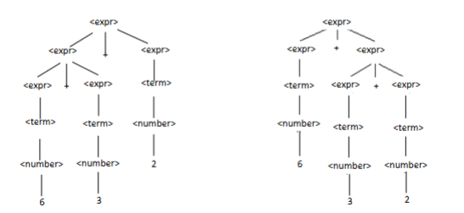

2025/09/15 - Lexical and Syntax Analysis & Implementation of Scanner
(Lecture 07)
Quiz 7.1: B
Quiz 7.2: C
Quiz 7.3: E

Lexical and Syntax Analysis
- Lexeme == Lowest unit of language
- Token == category of lexemes
- Language implementation systems must analyze source code
- Nearly all syntax analysis is based on formal descriptions of the syntax of the source language
- Syntactic Analysis
  - Consist of 2 parts
  - Lexical analyzer or scanner/lexer, finite automation based on regular grammar
  - Syntax analyzer or parser, push down automation based on context-free grammar (BNF)
- Parsing = process of determining if a string is a sentence
  - If it is, convert the concrete representation of that sentence into an abstract representation
  - Independent from tree
- Reasons to separate Lexical and Syntax Analysis
  - Simplicity - less complex approaches on lexical analysis to separate them from the parser
  - Efficiency - separation means more efficient
  - Portability - parser is always portable

Lexical Analysis or Scanning
- Lexical Analyzer
  - produces a pair of lexemes and Tokens
  - Front end for parser
  - Identifies substrings of the source program that belong together
  - Pattern matcher for character strings
- Scanner or Lexer >>> Implemented by Lexical Analyzer
  - Software that picks out lexemes, validates them, and returns a pair list of lexemes and tokens
  - Usually a function that is called by the parser when it needs next token
- Input Program >>>> Lexer >>>> Parser >>>> Abstract Syntax Tree
- int i = 20;
  - Lexemes == int, i, =, 20, ;
  - Tokens == reserved word, identifier, special symbol, literal, special symbol
  - 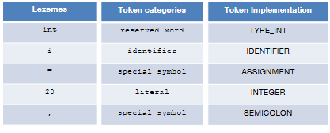
  - Steps the lexical analyzer takes here
    - Creates list of lexemes
    - Maps each lexeme into its distinct tokens, their implementation, not their category
- Building a lexical analyzer
  - You could Write a formal description of the tokens and use a software tool to make the table driven lexical analyzer from the description
  - You could also Make a diagram that describes tokens and constructs a table to make the analyzer from

Flex
- Modern version of Lex
- Takes regular expressions (patterns) as inputs, and outputs a file you slot into a C Compiler, which then gives you a list of tokens

2025/09/17 - Lab 1 part 2
(Lecture 08)
Quiz 8.0: B
Quiz 8.1: D
Quiz 8.2: D

2025/09/23 - Lab 01 part 3
(Lecture 09)
Quiz 9.1: D
Quiz 9.2: E
Quiz 9.3: D
Quiz 9.4: E
Quiz 9.5: A
Compilation: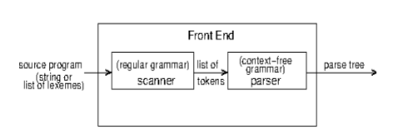
Interpretation:
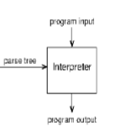

Compilation / Interpretation
- Compilation == Translates parse tree into another program
  - Translates code from one form to another form
- Interpretation
  - Takes in source program and produces output
  - Execute program directly from parse tree
  - You provide input, and it instantly runs, vs a compiler which changes it to another form
- Front End does not produce parse tree if the parse tree is invalid

2025/09/25 - Midterm Review
(Lecture 9.1)
- Basically review HW 1, HW 2, Lectures 1-9, Quiz Questions
  - Lec 1-2: What is a Programming Language
  - Lec 3-6: Regular Grammar, BNF/EBNF
  - Lec 7-9: Scanner + Parser
- Format
  - Short Response Questions on concepts
    - What is a programming language?
  - Regular Grammar and Scanning (HW 1, Lab 1)
    - Define regular grammar for identifiers?
  - BNF Grammar and Parsing (HW 2, Lab 1)
    - Basically all of HW 2
    - Prove this grammar in BNF is Ambiguous
    - What is a Compiler?
      - Translates code from one form to another form
  - Multiple Choice Questions
    - Quiz Questions
- Bring Written Notes

2025/10/09 - Functional Programming with Racket
(Lecture 10)

Functional Programming
- Based on von Neumann Architecture
  - Efficiency is the main concern
- Design of functional language based on math functions
- Programs work by returning values rather than modifying variables
- Function vs Procedures
  - Function returns values
  - Procedures don't return value and is evaluated for side effects
- Both above and programs can be represented as a mathematical concept of a function
- Functions = first-class

Mathematical Functions
- Lambda expression is a method to specify the parameters and mapping of a function

